1. **Agenda**:
   1. Let’s run our application to see how the configuration works.  
      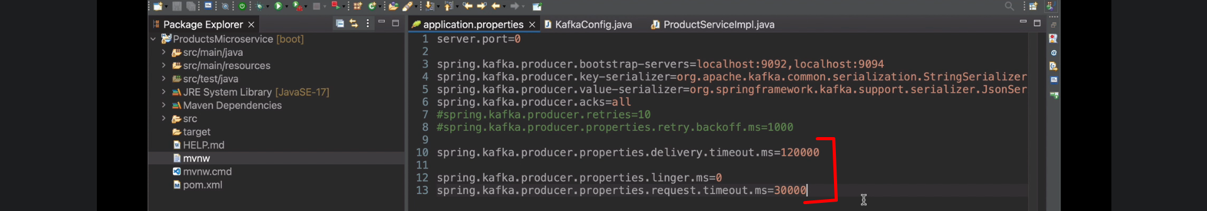
2. As we have configured min.insync.replicas=2, so minimum two brokers must be running but we have 3 brokers.
3. 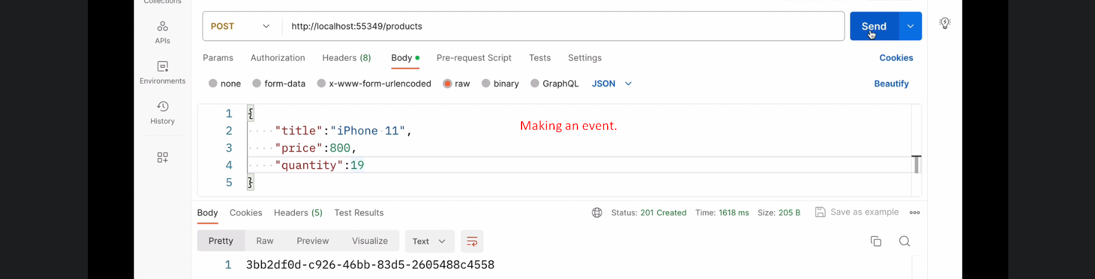  
   Which is successful.
4. Let’s terminate two brokers out of 3. Now we have only one broker.
5. As kafka producer is configured to get acknowledgement from two brokers but we have one. So producer will try again and again until it reaches the configured timeout of 2minutes -> delivery.timeout.ms=12000
6. 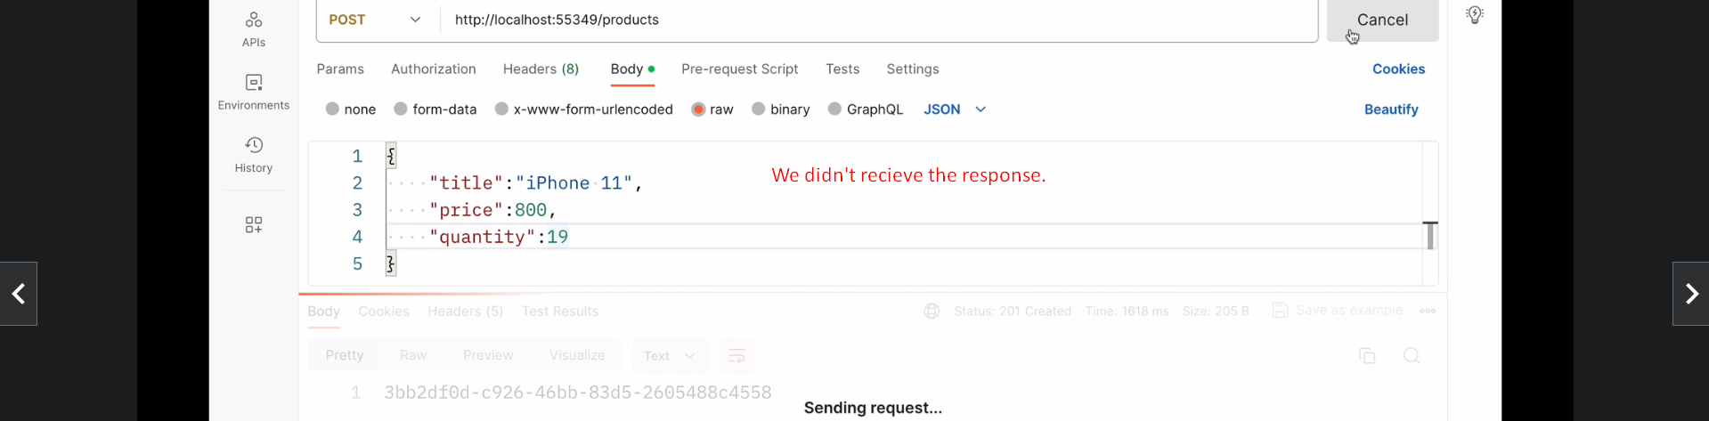
7. 
8. 